无Cu2+

|  |  |
| --- | --- |
| V(NaOH)/mL | pH |
| 0.00 | 1.95 |
| 2.00 | 2.12 |
| 4.00 | 2.35 |
| 6.00 | 2.70 |
| 7.00 | 2.97 |
| 8.00 | 3.46 |
| 8.50 | 4.44 |
| 8.54 | 4.94 |
| 8.60 | 5.99 |
| 8.65 | 7.10 |
| 8.68 | 8.87 |
| 8.74 | 9.64 |
| 8.80 | 9.84 |
| 8.85 | 10.01 |
| 8.90 | 10.13 |
| 8.93 | 10.23 |
| 9.00 | 10.34 |
| 9.51 | 10.85 |
| 9.99 | 11.06 |
| 11.00 | 11.34 |
| 12.00 | 11.51 |

有Cu2+

|  |  |
| --- | --- |
| V(NaOH)/mL | pH |
| 0.00 | 1.95 |
| 2.00 | 2.12 |
| 4.00 | 2.35 |
| 6.00 | 2.68 |
| 7.00 | 2.93 |
| 8.00 | 3.34 |
| 8.50 | 3.71 |
| 8.88 | 4.18 |
| 8.97 | 4.31 |
| 9.30 | 4.85 |
| 9.50 | 5.52 |
| 9.55 | 5.89 |
| 9.60 | 6.09 |
| 9.65 | 6.27 |
| 9.75 | 6.64 |
| 9.90 | 6.94 |
| 10.11 | 7.30 |
| 10.35 | 7.92 |
| 10.50 | 8.65 |
| 10.54 | 9.00 |
| 10.60 | 9.39 |
| 10.63 | 9.64 |
| 10.68 | 9.83 |
| 10.70 | 9.98 |
| 10.75 | 10.13 |
| 10.81 | 10.26 |
| 10.85 | 10.36 |
| 11.00 | 10.55 |
| 11.24 | 10.80 |
| 11.50 | 10.95 |
| 12.00 | 11.16 |
| 13.00 | 11.42 |

V(NaOH)c(NaOH)=2VLcL

解得cL=0.97226M

|  |  |  |  |  |  |  |
| --- | --- | --- | --- | --- | --- | --- |
| pH | V1 | V2 | V2-V1 | V总 | [L]配 | wpsoffice |
| 2.55 | 4.62500 | 4.75000 | 0.12500 | 54.75000 | 2.56621E-04 | 0.13523 |
| 2.75 | 5.78125 | 6.06250 | 0.28125 | 56.06250 | 5.63880E-04 | 0.30426 |
| 2.95 | 6.56250 | 6.87500 | 0.31250 | 56.87500 | 6.17582E-04 | 0.33807 |
| 3.15 | 7.18750 | 7.37500 | 0.18750 | 57.37500 | 3.67320E-04 | 0.20284 |
| 3.35 | 7.67969 | 7.84375 | 0.16406 | 57.84375 | 3.18801E-04 | 0.17748 |
| 3.55 | 7.89063 | 8.18750 | 0.29688 | 58.18750 | 5.73469E-04 | 0.32116 |
| 3.75 | 8.07031 | 8.43000 | 0.35969 | 58.43000 | 6.91920E-04 | 0.38911 |
| 3.95 | 8.21875 | 8.64250 | 0.42375 | 58.64250 | 8.12201E-04 | 0.45842 |
| 4.15 | 8.33656 | 8.81438 | 0.47781 | 58.81438 | 9.13146E-04 | 0.51690 |
| 4.35 | 8.42563 | 8.93625 | 0.51062 | 58.93625 | 9.73836E-04 | 0.55240 |
| 4.55 | 8.48594 | 9.09375 | 0.60781 | 59.09375 | 1.15610E-03 | 0.65754 |
| 4.75 | 8.51750 | 9.25063 | 0.73312 | 59.25063 | 1.39076E-03 | 0.79310 |
| 4.95 | 8.53344 | 9.31688 | 0.78344 | 59.31688 | 1.48454E-03 | 0.84753 |
| 5.15 | 8.54563 | 9.37500 | 0.82938 | 59.37500 | 1.57005E-03 | 0.89723 |
| 5.35 | 8.55906 | 9.42500 | 0.86594 | 59.42500 | 1.63789E-03 | 0.93678 |
| 5.55 | 8.57375 | 9.49688 | 0.92312 | 59.49688 | 1.74394E-03 | 0.99865 |
| 5.75 | 8.58109 | 9.51875 | 0.93766 | 59.51875 | 1.77075E-03 | 1.01437 |
| 5.95 | 8.59531 | 9.55625 | 0.96094 | 59.55625 | 1.81357E-03 | 1.03955 |
| 6.15 | 8.60219 | 9.59375 | 0.99156 | 59.59375 | 1.87019E-03 | 1.07268 |
| 6.35 | 8.61547 | 9.64688 | 1.03141 | 59.64688 | 1.94361E-03 | 1.11579 |
| 6.55 | 8.62188 | 9.71250 | 1.09063 | 59.71250 | 2.05294E-03 | 1.17985 |
| 6.75 | 8.63406 | 9.77188 | 1.13781 | 59.77188 | 2.13964E-03 | 1.23090 |
| 6.95 | 8.63969 | 9.88500 | 1.24531 | 59.88500 | 2.33737E-03 | 1.34719 |
| 7.15 | 8.64500 | 9.97875 | 1.33375 | 59.97875 | 2.49944E-03 | 1.44286 |
| 7.35 | 8.65000 | 10.08563 | 1.43563 | 60.08563 | 2.68557E-03 | 1.55307 |
| 7.55 | 8.65469 | 10.20000 | 1.54531 | 60.20000 | 2.88527E-03 | 1.67173 |
| 7.75 | 8.65906 | 10.26000 | 1.60094 | 60.26000 | 2.98615E-03 | 1.73191 |
| 7.95 | 8.66313 | 10.36313 | 1.70000 | 60.36313 | 3.16551E-03 | 1.83908 |
| 8.15 | 8.66688 | 10.40625 | 1.73938 | 60.40625 | 3.23652E-03 | 1.88167 |
| 8.35 | 8.67109 | 10.44375 | 1.77266 | 60.44375 | 3.29640E-03 | 1.91768 |
| 8.55 | 8.67578 | 10.47438 | 1.79859 | 60.47438 | 3.34294E-03 | 1.94574 |
| 8.75 | 8.68094 | 10.49813 | 1.81719 | 60.49813 | 3.37617E-03 | 1.96585 |
| 8.95 | 8.69266 | 10.52500 | 1.83234 | 60.52500 | 3.40282E-03 | 1.98225 |
| 9.15 | 8.69922 | 10.54875 | 1.84953 | 60.54875 | 3.43339E-03 | 2.00084 |
| 9.35 | 8.71375 | 10.59063 | 1.87688 | 60.59063 | 3.48174E-03 | 2.03042 |
| 9.55 | 8.72875 | 10.61125 | 1.88250 | 60.61125 | 3.49099E-03 | 2.03651 |
| 9.75 | 8.75125 | 10.63750 | 1.88625 | 60.63750 | 3.49643E-03 | 2.04056 |
| 9.95 | 8.80891 | 10.68750 | 1.87859 | 60.68750 | 3.47936E-03 | 2.03228 |
| 10.15 | 8.87188 | 10.73125 | 1.85938 | 60.73125 | 3.44129E-03 | 2.01149 |
| 10.35 | 8.94500 | 10.81375 | 1.86875 | 60.81375 | 3.45395E-03 | 2.02163 |
| 10.55 | 9.11625 | 10.94375 | 1.82750 | 60.94375 | 3.37050E-03 | 1.97701 |
| 10.75 | 9.35016 | 11.15000 | 1.79984 | 61.15000 | 3.30830E-03 | 1.94709 |
| 10.95 | 9.59859 | 11.33750 | 1.73891 | 61.33750 | 3.18652E-03 | 1.88117 |
| 11.15 | 10.00969 | 11.81250 | 1.80281 | 61.81250 | 3.27824E-03 | 1.95030 |
| 11.35 | 10.68422 | 12.37500 | 1.69078 | 62.37500 | 3.04679E-03 | 1.82910 |

|  |  |  |  |  |  |  |  |  |
| --- | --- | --- | --- | --- | --- | --- | --- | --- |
| pH | V2-V1 | V总 | [L]配 | [H+] | αL(H) | lgαL(H) | [L3-] | lg[L3-] |
| 2.55 | 0.12500 | 54.75000 | 2.56621E-04 | 2.81838E-03 | 2.38094E+09 | 9.37675 | 1.38391E-12 | -11.85889 |
| 2.75 | 0.28125 | 56.06250 | 5.63880E-04 | 1.77828E-03 | 1.20913E+09 | 9.08247 | 2.40222E-12 | -11.61939 |
| 2.95 | 0.31250 | 56.87500 | 6.17582E-04 | 1.12202E-03 | 6.46210E+08 | 8.81037 | 4.33505E-12 | -11.36301 |
| 3.15 | 0.18750 | 57.37500 | 3.67320E-04 | 7.07946E-04 | 3.61271E+08 | 8.55783 | 8.36441E-12 | -11.07756 |
| 3.35 | 0.16406 | 57.84375 | 3.18801E-04 | 4.46684E-04 | 2.09451E+08 | 8.32108 | 1.45279E-11 | -10.83780 |
| 3.55 | 0.29688 | 58.18750 | 5.73469E-04 | 2.81838E-04 | 1.24791E+08 | 8.09618 | 2.21839E-11 | -10.65396 |
| 3.75 | 0.35969 | 58.43000 | 6.91920E-04 | 1.77828E-04 | 7.58065E+07 | 7.87971 | 3.47731E-11 | -10.45876 |
| 3.95 | 0.42375 | 58.64250 | 8.12201E-04 | 1.12202E-04 | 4.66636E+07 | 7.66898 | 5.36539E-11 | -10.27040 |
| 4.15 | 0.47781 | 58.81438 | 9.13146E-04 | 7.07946E-05 | 2.89782E+07 | 7.46207 | 8.25812E-11 | -10.08312 |
| 4.35 | 0.51062 | 58.93625 | 9.73836E-04 | 4.46684E-05 | 1.80990E+07 | 7.25766 | 1.28489E-10 | -9.89113 |
| 4.55 | 0.60781 | 59.09375 | 1.15610E-03 | 2.81838E-05 | 1.13461E+07 | 7.05485 | 1.88124E-10 | -9.72556 |
| 4.75 | 0.73312 | 59.25063 | 1.39076E-03 | 1.77828E-05 | 7.12958E+06 | 6.85306 | 2.65247E-10 | -9.57635 |
| 4.95 | 0.78344 | 59.31688 | 1.48454E-03 | 1.12202E-05 | 4.48679E+06 | 6.65194 | 3.99762E-10 | -9.39820 |
| 5.15 | 0.82938 | 59.37500 | 1.57005E-03 | 7.07946E-06 | 2.82633E+06 | 6.45122 | 6.03232E-10 | -9.21952 |
| 5.35 | 0.86594 | 59.42500 | 1.63789E-03 | 4.46684E-06 | 1.78144E+06 | 6.25077 | 9.17425E-10 | -9.03743 |
| 5.55 | 0.92312 | 59.49688 | 1.74394E-03 | 2.81838E-06 | 1.12328E+06 | 6.05049 | 1.35703E-09 | -8.86741 |
| 5.75 | 0.93766 | 59.51875 | 1.77075E-03 | 1.77828E-06 | 7.08448E+05 | 5.85031 | 2.11212E-09 | -8.67528 |
| 5.95 | 0.96094 | 59.55625 | 1.81357E-03 | 1.12202E-06 | 4.46884E+05 | 5.65019 | 3.24792E-09 | -8.48839 |
| 6.15 | 0.99156 | 59.59375 | 1.87019E-03 | 7.07946E-07 | 2.81919E+05 | 5.45012 | 4.94032E-09 | -8.30624 |
| 6.35 | 1.03141 | 59.64688 | 1.94361E-03 | 4.46684E-07 | 1.77861E+05 | 5.25008 | 7.40157E-09 | -8.13068 |
| 6.55 | 1.09063 | 59.71250 | 2.05294E-03 | 2.81838E-07 | 1.12215E+05 | 5.05005 | 1.07252E-08 | -7.96960 |
| 6.75 | 1.13781 | 59.77188 | 2.13964E-03 | 1.77828E-07 | 7.08006E+04 | 4.85004 | 1.57287E-08 | -7.80331 |
| 6.95 | 1.24531 | 59.88500 | 2.33737E-03 | 1.12202E-07 | 4.46714E+04 | 4.65003 | 2.03648E-08 | -7.69112 |
| 7.15 | 1.33375 | 59.97875 | 2.49944E-03 | 7.07946E-08 | 2.81856E+04 | 4.45003 | 2.63457E-08 | -7.57929 |
| 7.35 | 1.43563 | 60.08563 | 2.68557E-03 | 4.46684E-08 | 1.77841E+04 | 4.25003 | 3.09645E-08 | -7.50914 |
| 7.55 | 1.54531 | 60.20000 | 2.88527E-03 | 2.81838E-08 | 1.12213E+04 | 4.05004 | 3.07301E-08 | -7.51244 |
| 7.75 | 1.60094 | 60.26000 | 2.98615E-03 | 1.77828E-08 | 7.08051E+03 | 3.85006 | 3.39995E-08 | -7.46853 |
| 7.95 | 1.70000 | 60.36313 | 3.16551E-03 | 1.12202E-08 | 4.46786E+03 | 3.65010 | 1.25031E-08 | -7.90298 |
| 8.15 | 1.73938 | 60.40625 | 3.23652E-03 | 7.07946E-09 | 2.81939E+03 | 3.45016 | -6.18729E-09 | -8.20850 |
| 8.35 | 1.77266 | 60.44375 | 3.29640E-03 | 4.46684E-09 | 1.77928E+03 | 3.25024 | -4.45813E-08 | -7.35085 |
| 8.55 | 1.79859 | 60.47438 | 3.34294E-03 | 2.81838E-09 | 1.12302E+03 | 3.05039 | -1.13525E-07 | -6.94491 |
| 8.75 | 1.81719 | 60.49813 | 3.37617E-03 | 1.77828E-09 | 7.08946E+02 | 2.85061 | -2.28489E-07 | -6.64113 |
| 8.95 | 1.83234 | 60.52500 | 3.40282E-03 | 1.12202E-09 | 4.47684E+02 | 2.65097 | -4.24543E-07 | -6.37208 |
| 9.15 | 1.84953 | 60.54875 | 3.43339E-03 | 7.07946E-10 | 2.82838E+02 | 2.45154 | -7.84520E-07 | -6.10540 |
| 9.35 | 1.87688 | 60.59063 | 3.48174E-03 | 4.46684E-10 | 1.78828E+02 | 2.25244 | -1.52361E-06 | -5.81713 |
| 9.55 | 1.88250 | 60.61125 | 3.49099E-03 | 2.81838E-10 | 1.13202E+02 | 2.05385 | -2.49821E-06 | -5.60237 |
| 9.75 | 1.88625 | 60.63750 | 3.49643E-03 | 1.77828E-10 | 7.17946E+01 | 1.85609 | -4.03416E-06 | -5.39425 |
| 9.95 | 1.87859 | 60.68750 | 3.47936E-03 | 1.12202E-10 | 4.56684E+01 | 1.65962 | -6.02632E-06 | -5.21995 |
| 10.15 | 1.85938 | 60.73125 | 3.44129E-03 | 7.07946E-11 | 2.91838E+01 | 1.46514 | -8.20469E-06 | -5.08594 |
| 10.35 | 1.86875 | 60.81375 | 3.45395E-03 | 4.46684E-11 | 1.87828E+01 | 1.27376 | -1.36533E-05 | -4.86476 |
| 10.55 | 1.82750 | 60.94375 | 3.37050E-03 | 2.81838E-11 | 1.22202E+01 | 1.08708 | -1.47151E-05 | -4.83224 |
| 10.75 | 1.79984 | 61.15000 | 3.30830E-03 | 1.77828E-11 | 8.07946E+00 | 0.90738 | -1.58897E-05 | -4.79888 |
| 10.95 | 1.73891 | 61.33750 | 3.18652E-03 | 1.12202E-11 | 5.46684E+00 | 0.73774 | -2.98538E-06 | -5.52500 |
| 11.15 | 1.80281 | 61.81250 | 3.27824E-03 | 7.07946E-12 | 3.81838E+00 | 0.58188 | -3.46750E-05 | -4.45998 |
| 11.35 | 1.69078 | 62.37500 | 3.04679E-03 | 4.46684E-12 | 2.77828E+00 | 0.44378 | 2.54375E-05 | -4.59453 |

根据以上数据作图如下：

滴定曲线：

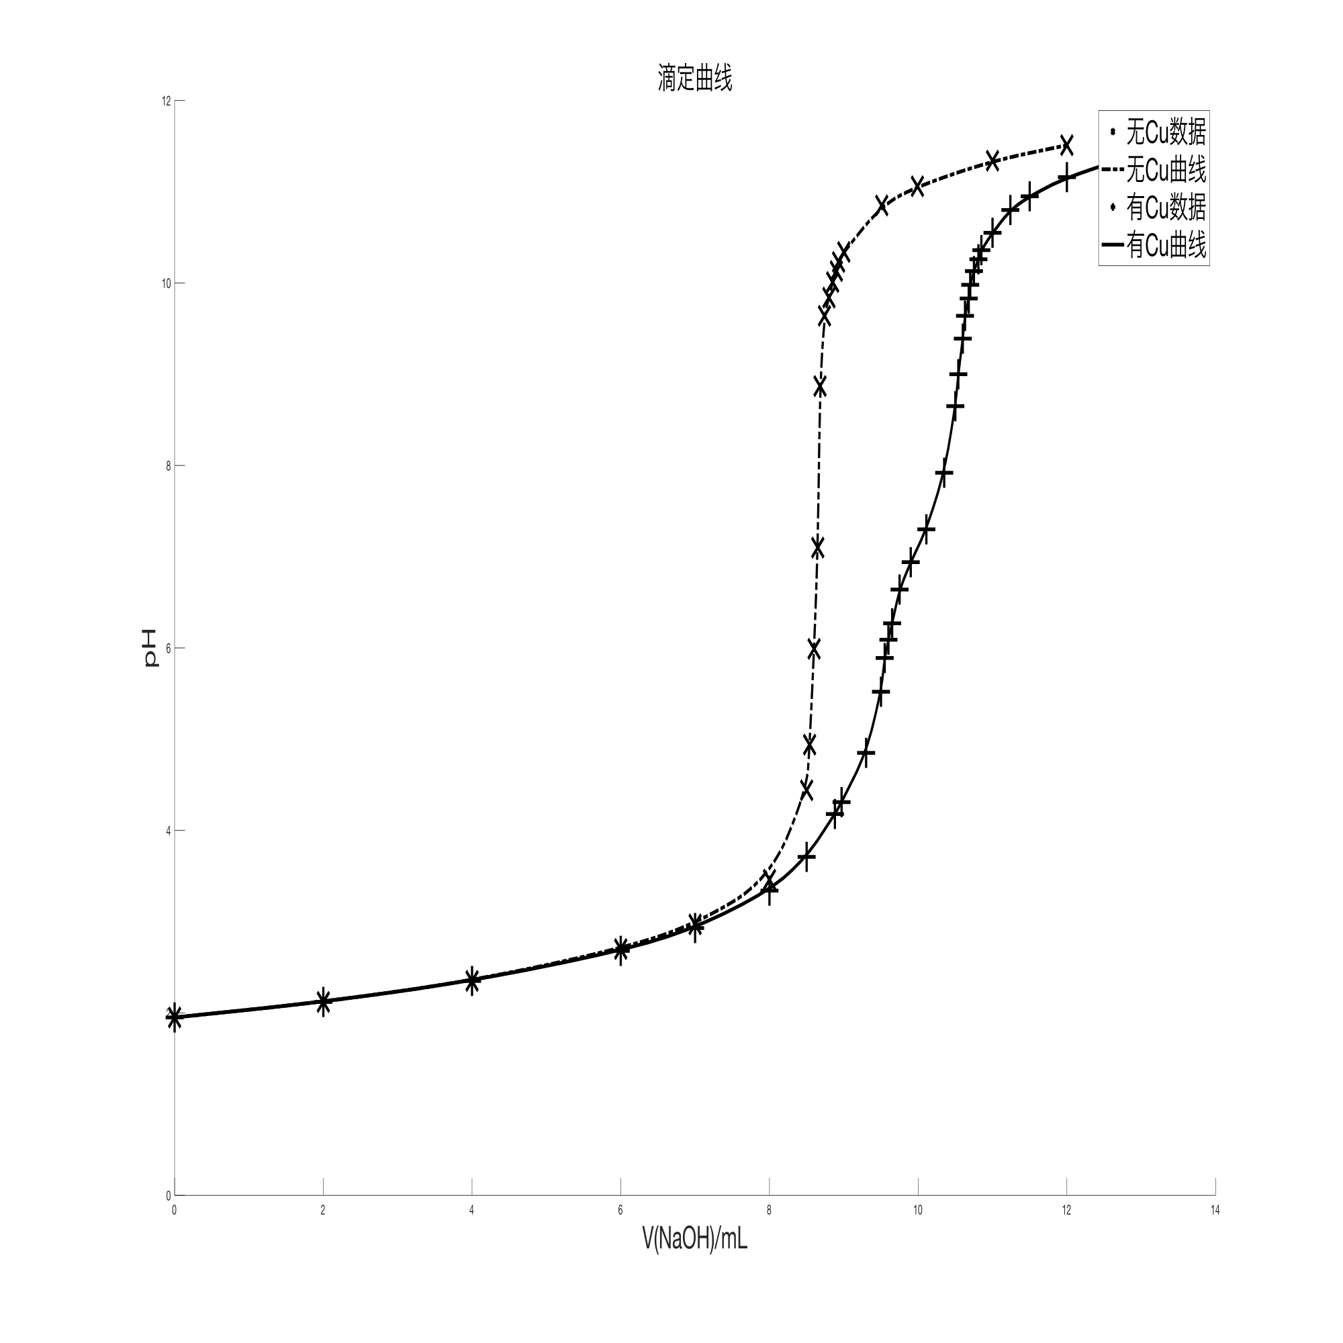

滴定曲线一阶导数：

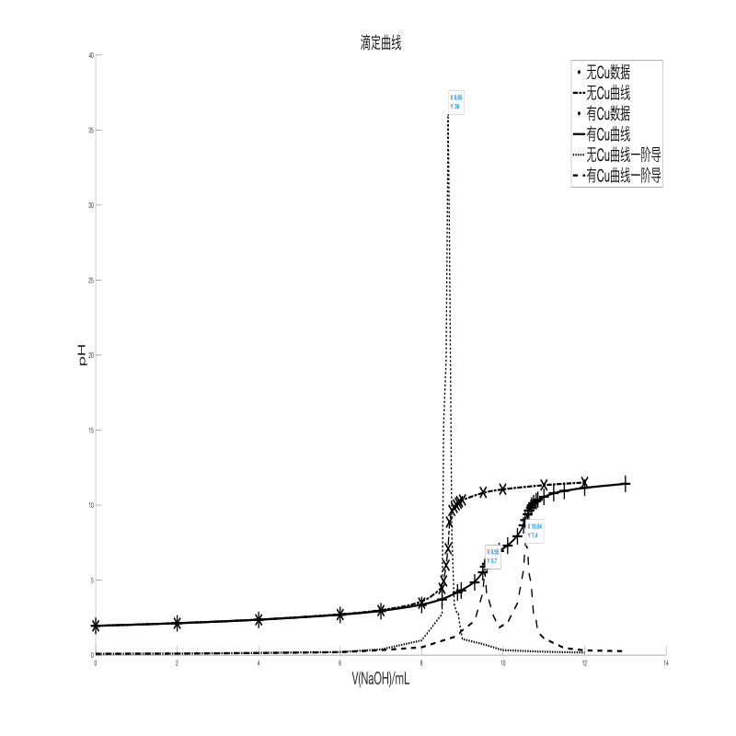

终点pH=8.65，9.55，10.54

wpsoffice图

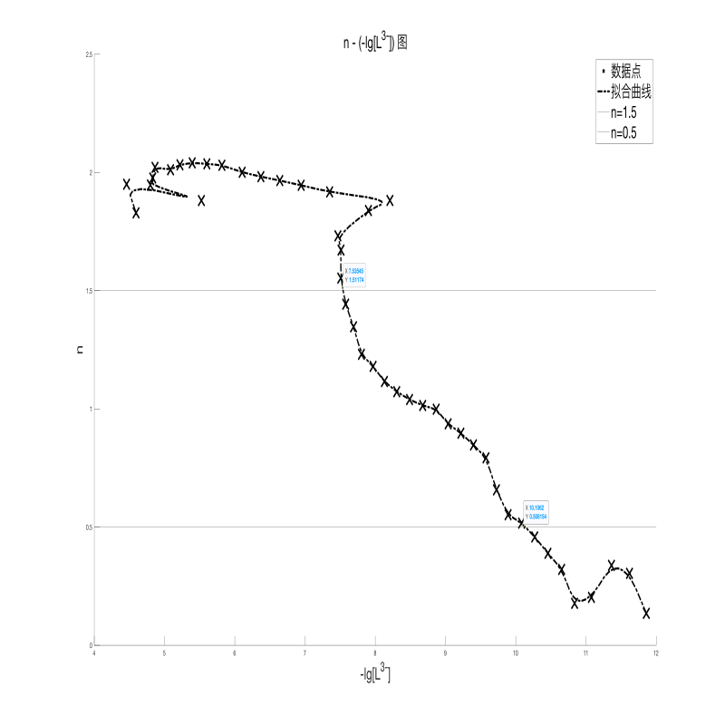

n=1.5, -lg[L3-]=7.53545=lgK2, K2=107.53545=3.43×107

n=0.5, -lg[L3-]=10.1062=lgK1, K1=1010.1062=1.27×1010